Cytology is the study of CELLS. STUDY GUIDE – CH. 5 BIOLOGY 9-18-23
Student’s Name __________________________ Parent’s Signature _____________________________
I. History of Cells
1. 1665-Robert Hooke-cork-microscope-cells (little boxes)
2. 1682-A. Leuwenhoek-cells come from other living material
3. 1837-Schwann-animals have cells (SWAN); Schleiden-plants have cells
II. Cell Theory
1. Cells are the basic units that make up all living things.
2. Cells come from preexisting cells
3. Cells carry on the functions of all living things.
III. Why are cells so small?
1. The DNA code of the cell regulates it size.
2. The ratio between the surface area and the volume of the cell influences its nutrition and thus the size of the cell.
In large cells, the surface area is too small to provide adequate nutrients to the interior of the cell.
III. Organizing with Cells
A. Number of Cells Necessary to Fully Function
1. Unicellular-an organism made of only one cell that can fully function without other cells. Some unicellular organisms join with others to form a colony in which each performs a specific task.
2. Multicellular-two or more cells that are highly specialized and depend on each other to function
Two or more cells that perform a special function form tissue. Different tissues work together to form organs. Different organs work together to form an organ system.
B. Kind of Parts – organelles “little organs”
1. Eukaryotic Membrane-surrounded organelles including nucleus {animals, plants}
2.Prokaryotic Lack surrounding membranes no nucleus {bacteria}
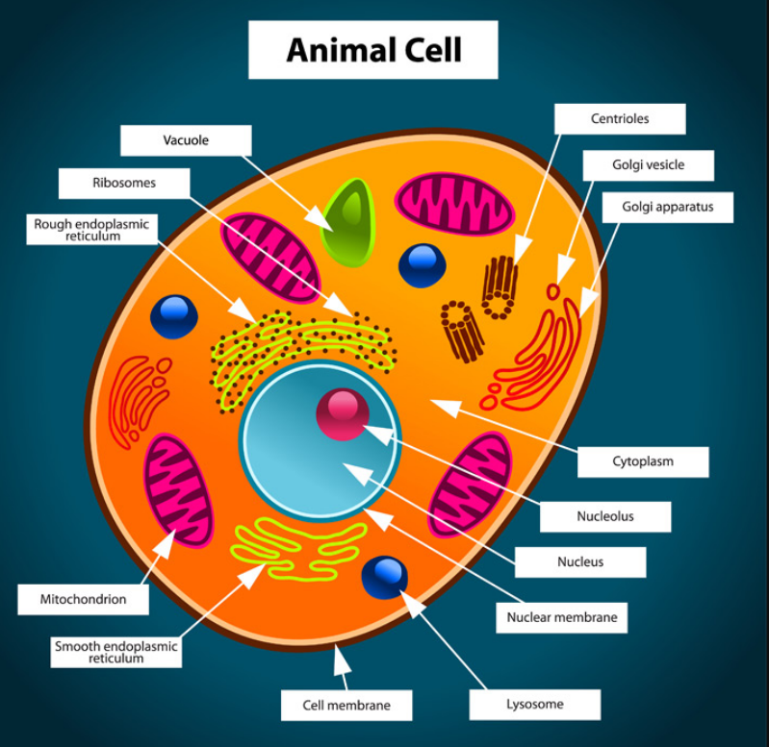
a. Animal cell organelles (know the appearance and function)mitochondria-powerhouse
2. Golgi apparatus-packages or processes chemicals like polysaccharides (sugars)post office
3. ribosomes-synthesize make protein
4. endoplasmic reticulum –
passageways where chemicals are made; folded plasma membrane
5. nucleus-control center-stores hereditary information
6. centrioles-organize motion of chromosomes
7. nucleolus-manufactures
ribosomes
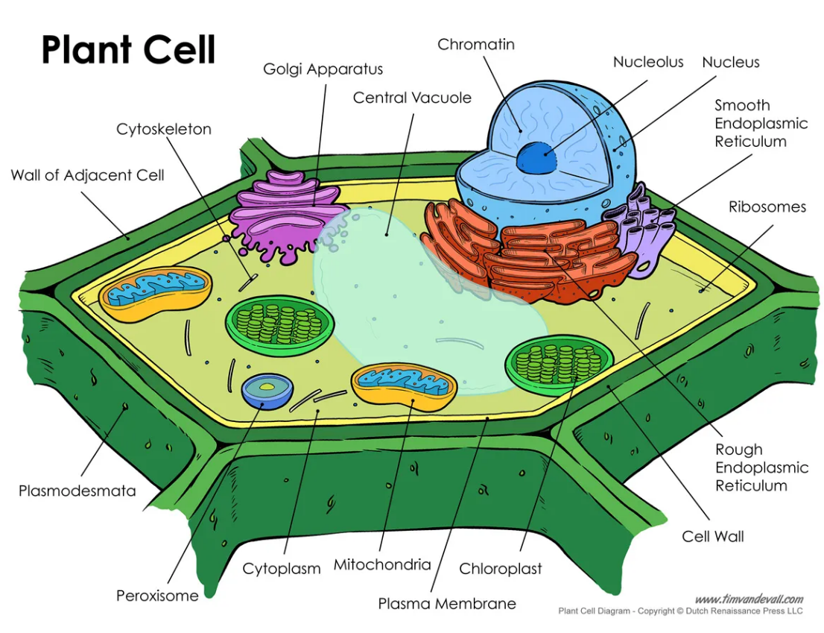
8. vacuole-stores water &nutrients
9. lysosomes-Waste disposal plant
10. cytoskeleton-microtubules are thickest, important to organization of cell and cellular movement
PLANT CELL
1. chloroplasts-photosynthesis (only in plants)
2. central vacuole-vesicle that stores water & nutrients, helps maintain the shape in a plant cell, turgor pressure from water pushes against cell wall to make rigid (only in plants)
3. cell wall-rigid, porous layer of a plant cell that contains cellulose (only in plants)
4. plastid-small structure than can store food (leucoplast only in plants; other examples are chloroplasts, chromoplasts)
Balance in the Cell
1. Homeostasis or dynamic equilibrium-affected by temperature, nutrition, illness
2. Optimal range-ideal conditions for cells to work
3. Range of tolerance-below this range, cells die (skin cells very sensitive; i.e. frostbite, sunburn)
Solutions and the Cell
1. Hypertonic solution -more concentrated, contains more solute (i.e. ocean water); causes a cell to shrivel
2. Isotonic-equal concentration; cell maintains shape
3. Hypotonic-less concentrated; contains less solute; causes movement of solution into cell to expand
Transport Across the Membrane
A. Passive transport-Movement without chemical energy
1. Diffusion-solute particles move from an area of high concentration to a lower concentration gradient
2. Osmosis-osmosis is the movement of water molecules from an area of high concentration to an area of low concentration through a semipermeable membrane

3. Facilitated diffusion-molecules move with the help of transport proteins
B. Active transport-movement of molecules across the membrane using chemical energy
1. Because of size, shape, polarity, or composition of cell membrane, extra energy is needed to move from an area of low to high concentration to cross the cell membrane.

2. Two additional types of active transport include: endocytosis-the cell engulfs (IN) the particle and pinches it off into a vesicle. (EATS IT-known as PHAGOCYTOSIS or DRINKS IT – known as PINOCYTOSIS); exocytosis-the vesicle fuses with the cell membrane and is exited (OUT) out of the cell

